Practical 15: Personal Financial Planner

Aim
To prepare a personal financial planner using Excel.

Objectives
•To track expenses
•To compare budget vs actual

Materials Required
•Excel

Procedure
1. Enter expenses
Record all expense items with their categories, dates, and amounts in the spreadsheet.
2. Apply Data Validation
Set validation rules to restrict inputs, such as allowing only numbers or predefined categories.
3. Use SUMIF
Use the SUMIF function to total expenses by category or any specific condition you choose.
4. Create budget sheet
Design a separate sheet comparing planned budgets to actual spending for better tracking.
5. Highlight expenses above limit
Apply conditional formatting to automatically mark entries that exceed your budget limit.

6. Create charts
Generate charts to visually present spending patterns, category breakdowns, or monthly totals.
7. Adjust print settings
Modify page layout, scaling, and margins to ensure the sheet prints clearly and fits on the page.

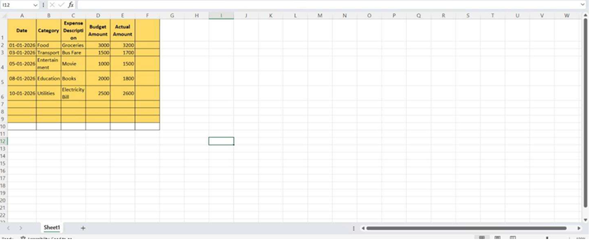
Output:
